ARCH TECHNOLOGIES

Name : Kinza Wakeel

Domain : Cybersecurity Intern

Email Address: kinzawakeel3@gmail.com

Task 3: Lost Data Retrieval

Simulate a scenario where files are accidentally deleted from a storage
device and use basic data recovery tools or techniques to attempt
retrieval. Work with file systems like FAT32 or NTFS, explore tools such
as Recuva or Test Disk, and document the recovery steps and results in
a safe, test environment.

Lost Data Retrieval Using Recuva and Python Analysis

1. SUMMARY
This project demonstrates the process of recovering accidentally deleted files from a storage device using data recovery tools in a safe test environment. The experiment was performed on a Windows system using the NTFS file system. Different files such as documents, images, and PDFs were intentionally deleted using Shift + Delete to simulate accidental data loss.
The recovery process was carried out using the Recuva recovery tool. Additionally, a Python script was created to analyze and verify recovered files automatically. The project successfully demonstrated that deleted files can often be restored if recovery is attempted before data is overwritten.

2. LAB OBJECTIVES
The objectives of this lab were:
- To understand the concept of lost data retrieval.
- To simulate accidental file deletion in a safe environment.
- To recover deleted files using Recuva.
- To explore file systems such as NTFS and FAT32.
- To verify recovered files using Python automation.
- To understand the importance of backup and recovery techniques.

3. LAB ENVIRONMENT
Component | Details
Operating System | Windows 10/11
File System | NTFS
Recovery Tool | Recuva
Additional Tool | Python 3
IDE Used | Visual Studio Code
Test Environment | Desktop Test Folder

4. INTRODUCTION
Lost data retrieval is the process of recovering deleted, corrupted, or inaccessible files from storage devices. Data loss may occur because of accidental deletion, formatting, malware attacks, or hardware failure.
Modern recovery tools scan storage devices and attempt to restore deleted files before they are permanently overwritten. In this project, Recuva was used as the primary recovery tool because it provides a simple interface and supports deep scanning of deleted files.
A Python script was also used to automate the verification process of recovered files.

5. FILE SYSTEM OVERVIEW

NTFS (New Technology File System)
NTFS is the default file system used in modern Windows operating systems. It provides:
- Better security
- File permissions
- Faster recovery support
- Large file storage
The experiment in this project was performed on an NTFS file system.

FAT32 (File Allocation Table 32)
FAT32 is an older file system commonly used in USB drives and memory cards. It is compatible with many operating systems but has limitations such as:
- Maximum file size limit of 4GB
- Lower security features
- Less efficient recovery support

6. TASKS PERFORMED

TASK 1 — Creating the Test Environment
A separate project folder was created on the desktop to safely perform recovery operations without affecting personal files.
Folders created:
- LostDataRecovery_Project
- TestFiles
- RecoveredFiles
- Screenshots

Project Folder Structure
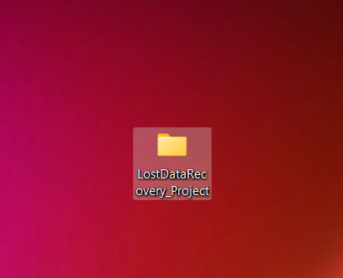

Explanation
This screenshot shows the folders created for performing the lost data retrieval experiment in a safe environment.

TASK 2 — Creating Dummy Files
Several dummy files were created inside the TestFiles folder, including:
- Word documents
- Text files
- Images
- PDF files
These files were used to simulate real-world user data.

Test Files Created
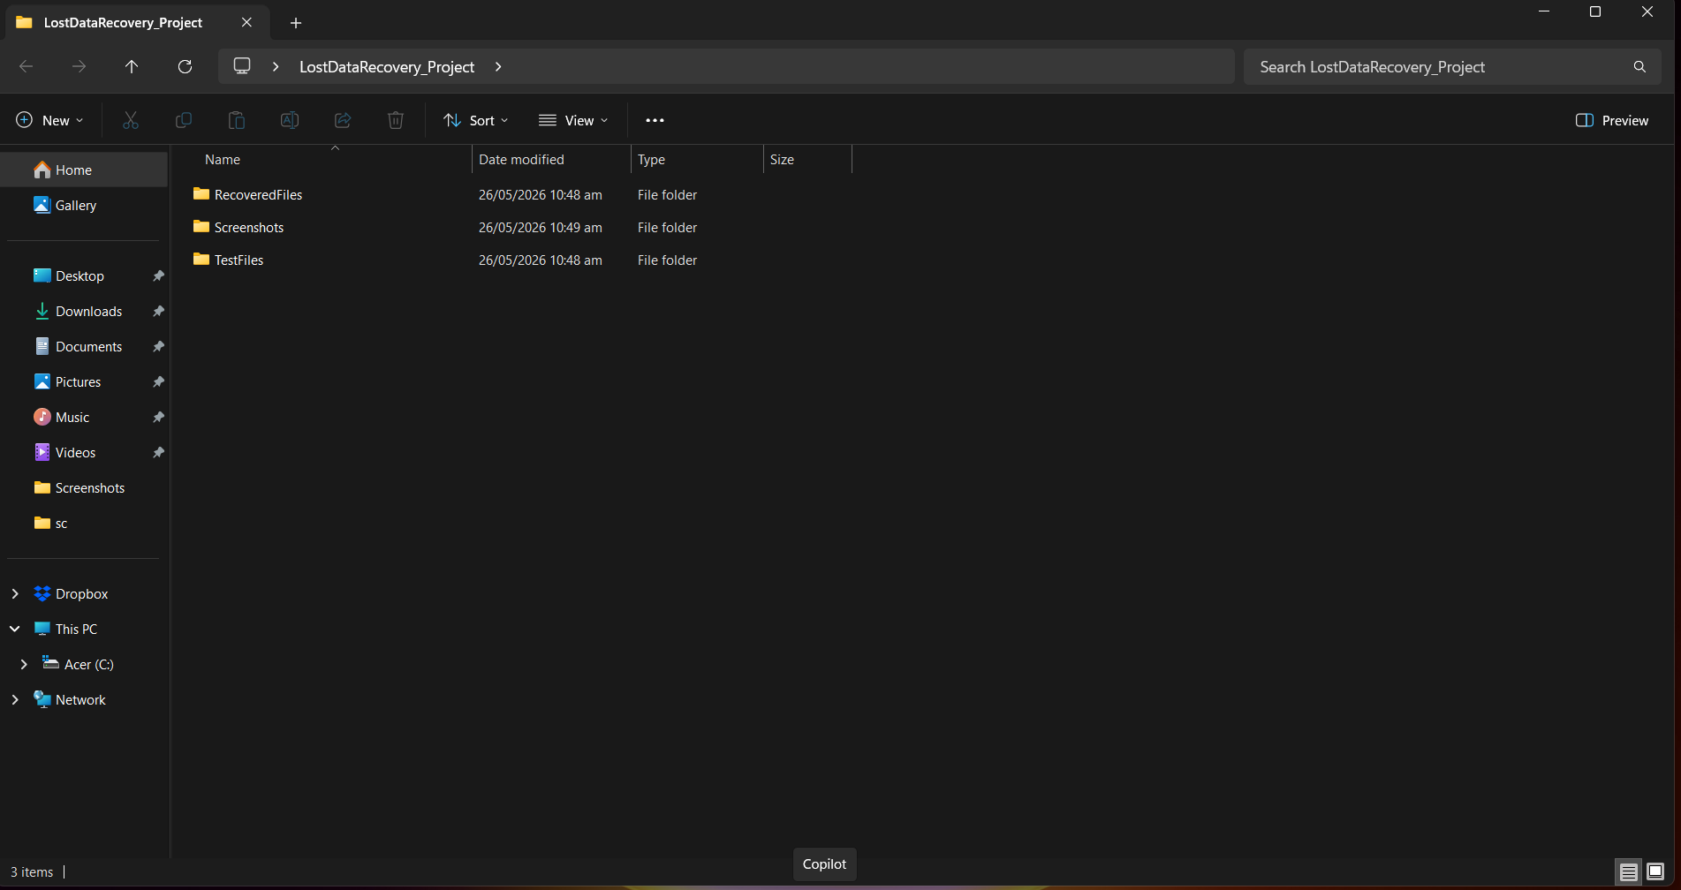

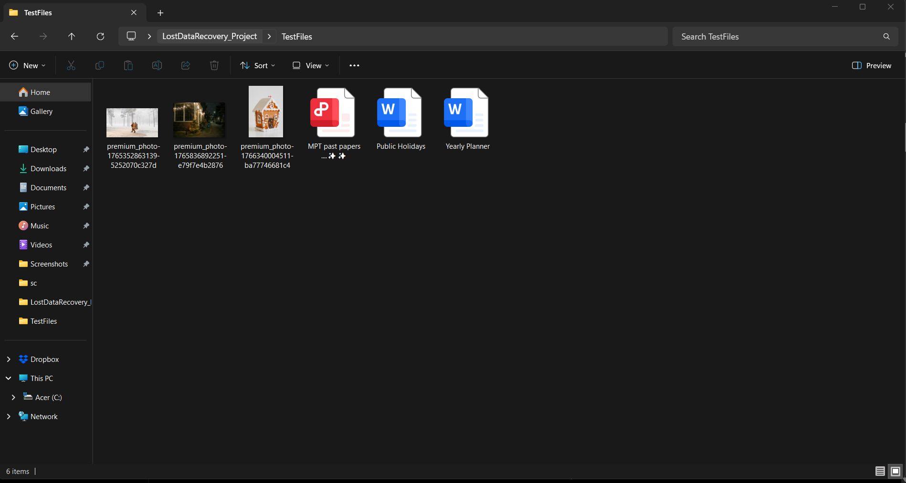

Explanation
This screenshot displays the sample files created before deletion.

TASK 3 — Simulating Accidental Deletion
Selected files were permanently deleted using Shift + Delete to simulate accidental data loss.
Deleted files included:
- Assignment.docx
- Report.pdf
- Photo1.jpg

File Deletion Confirmation
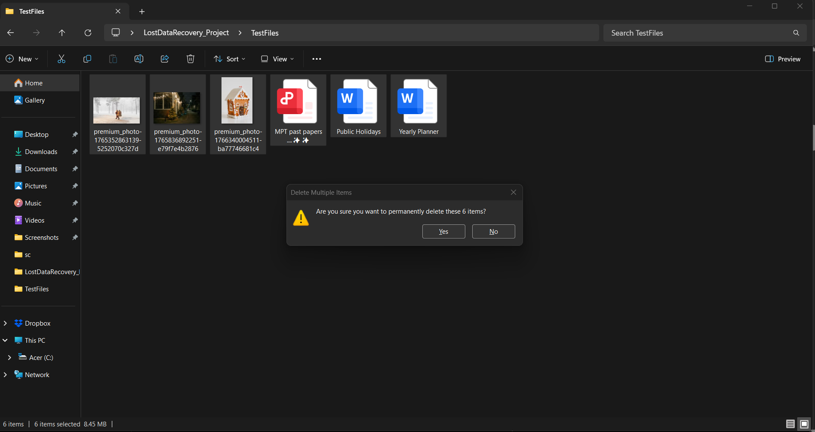

Explanation
This screenshot shows the permanent deletion confirmation window used to simulate accidental data loss.

TASK 4 — Installing Recuva
The Recuva recovery tool was downloaded and installed on the Windows system.

Recuva Installation
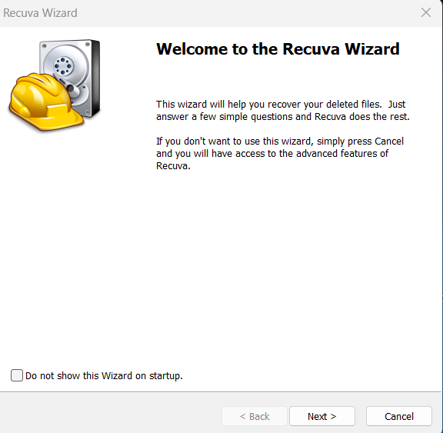

Explanation
This screenshot shows the successful installation of the Recuva recovery tool.

TASK 5 — Performing Deep Scan
Recuva was configured to:
- Scan all file types
- Search inside the TestFiles folder
- Perform a deep scan

Recuva Scan Settings
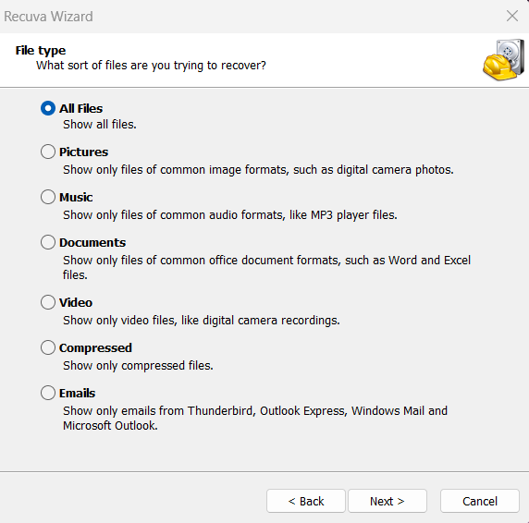

Explanation
This screenshot shows the scan configuration used to locate deleted files.

TASK 6 — Recovering Deleted Files
After scanning, deleted files were detected successfully. The selected files were restored into the RecoveredFiles folder.

Deleted Files Found

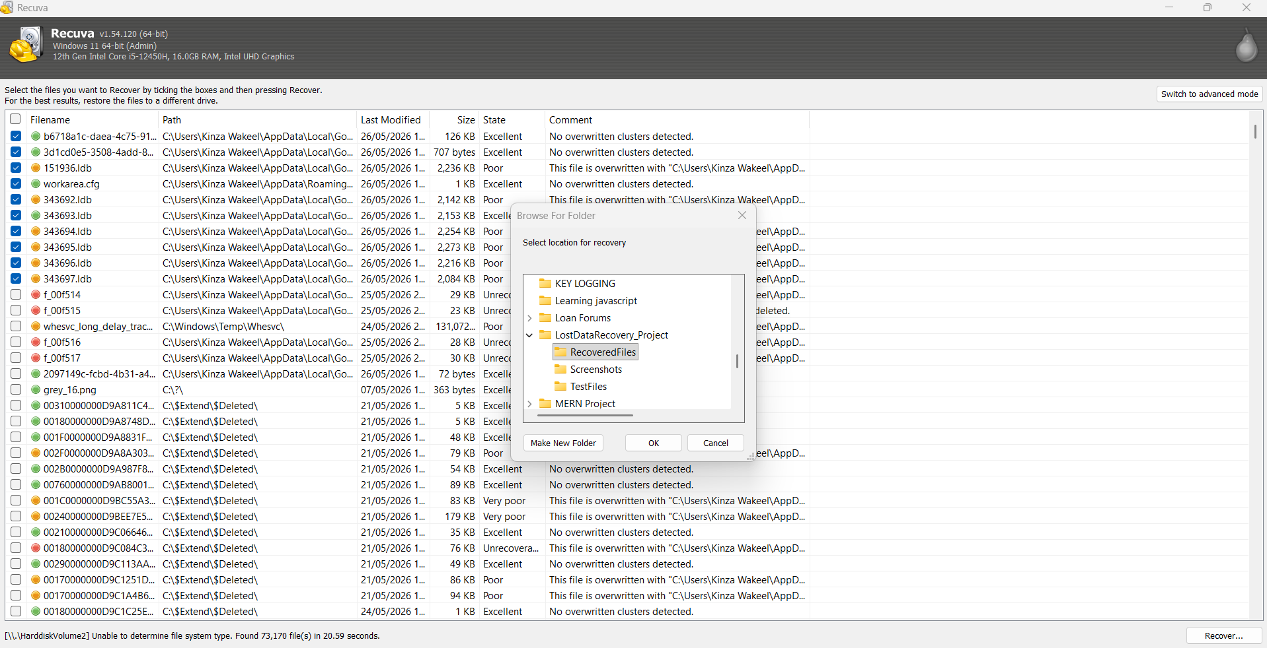

Explanation
This screenshot shows the deleted files identified by Recuva during the scan process.

Recovery Successful
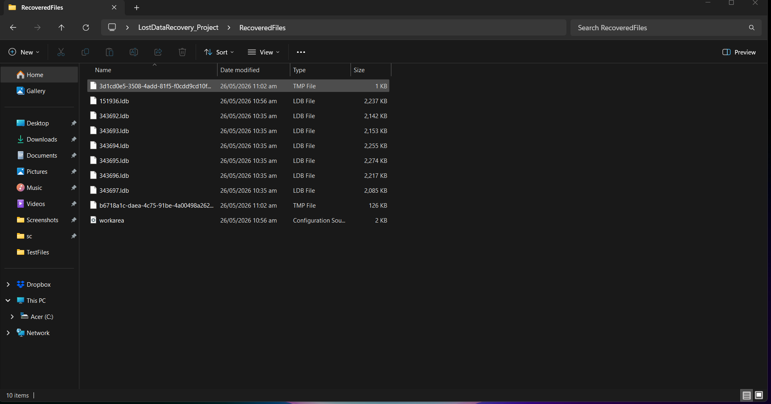

Explanation
This screenshot confirms that the deleted files were successfully recovered.

TASK 8 — Python Automation for File Analysis
A Python script was created in Visual Studio Code to automatically analyze recovered files and display:
- File names
- File sizes
- Total recovered files

Python Recovery Script
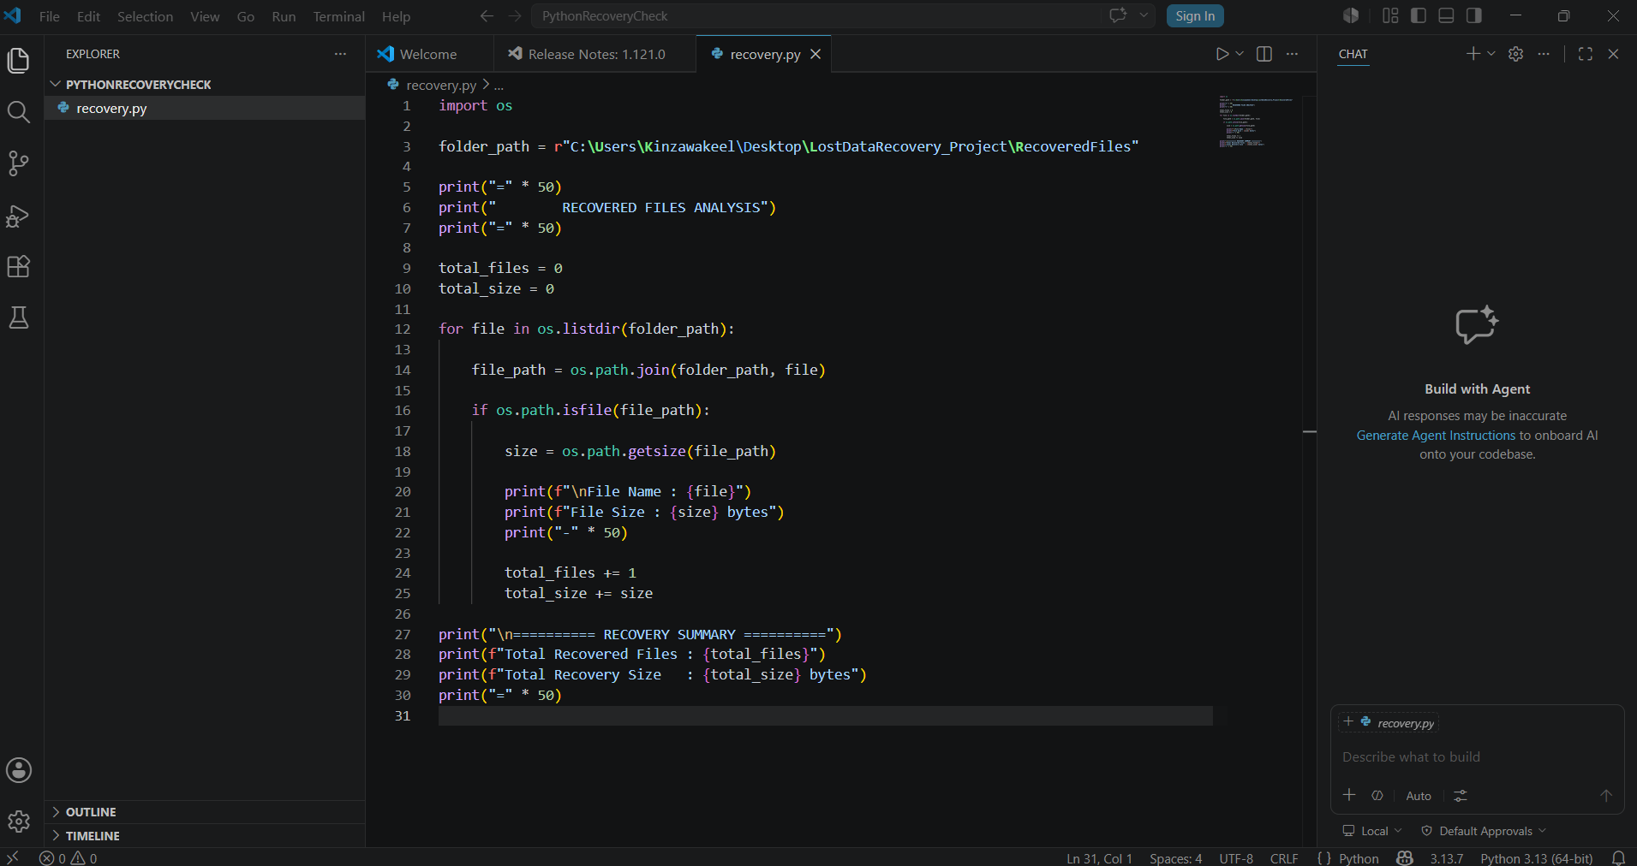

Explanation
This screenshot displays the Python script used for automated recovered file analysis.

Python Script Output

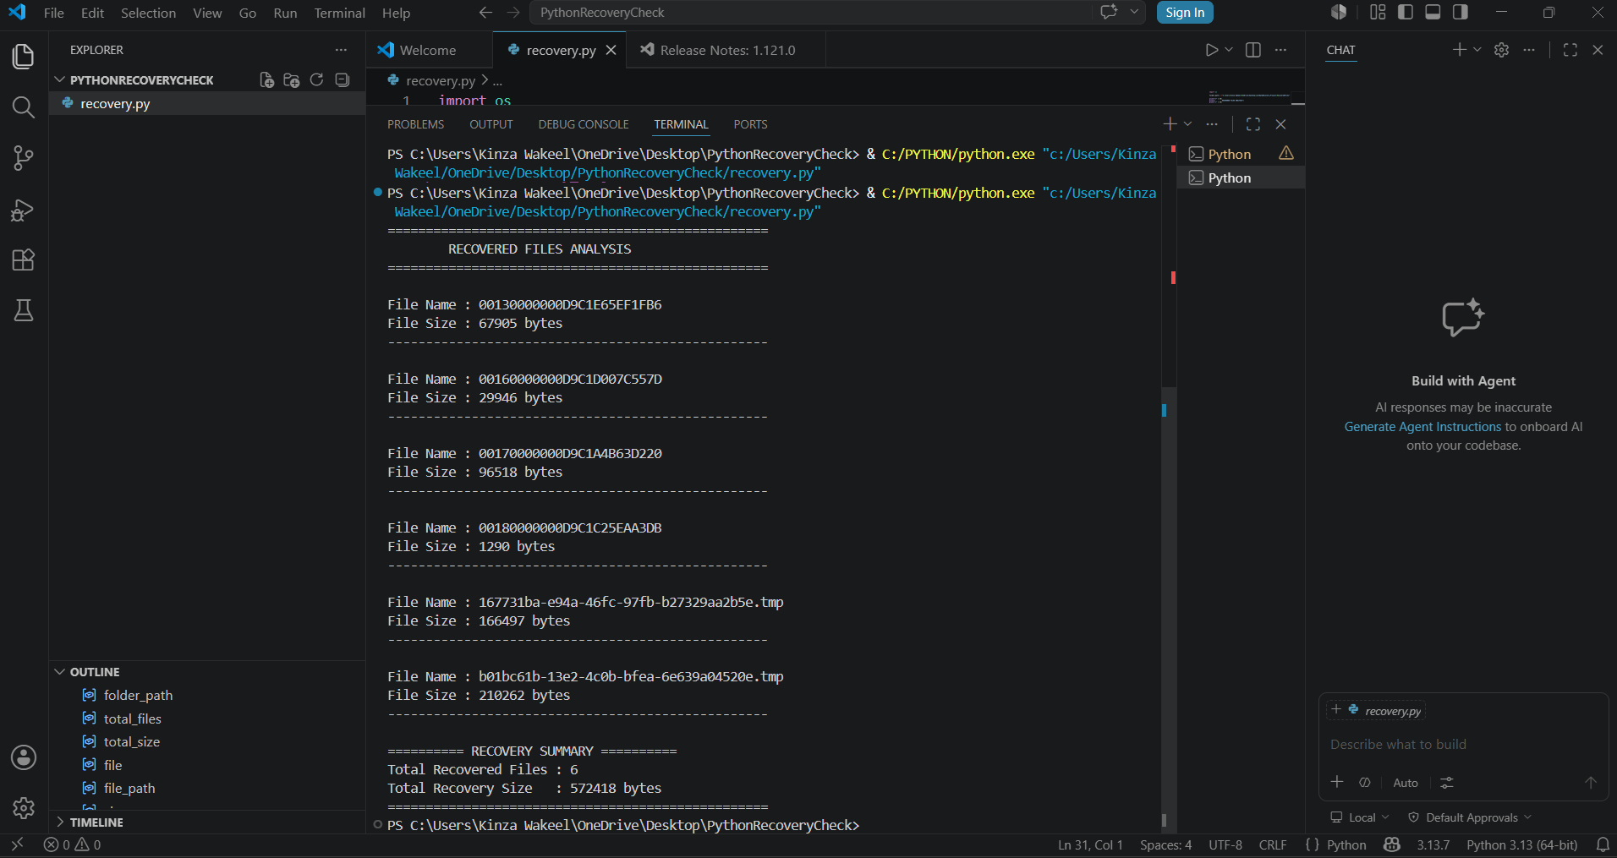

Explanation
This screenshot shows the terminal output generated by the Python recovery analysis script.

7. RESULTS
The deleted files were successfully recovered using Recuva. Most recovered files were fully accessible and functional after restoration.
The Python script also verified:
- File existence
- File sizes
- Total number of recovered files
The experiment demonstrated that deleted data can often be restored if recovery is performed before the storage sectors are overwritten.

8. CHALLENGES FACED
During the project, the following challenges were encountered:
- Incorrect folder paths in the Python script
- File recovery scan taking extra time during deep scan
- Some files initially not appearing during scanning
These issues were resolved by correcting file paths and enabling deep scan mode.

9. CONCLUSION
This project successfully demonstrated the process of lost data retrieval using Recuva in a Windows NTFS environment. Deleted files were intentionally removed and later recovered using recovery techniques.
Additionally, Python automation was used to verify recovered files and improve analysis efficiency. The project highlighted the importance of recovery tools, safe testing environments, and backup practices in cybersecurity and digital forensics.

10. TOOLS USED
- Recuva
- Python 3
- Visual Studio Code
- Windows 10

